
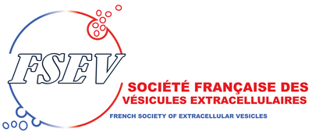


Short talk session

Submission form

Please complete the present submission form and upload it on the registration form by April 15, 2025.
Selection will be confirmed on May 15, 2025.

Poster :

Title of the abstract
Authors and affiliations
Laboratory
Email address main author
Abstract about 200 à 300 words
In English

Keywords

